Profile of the

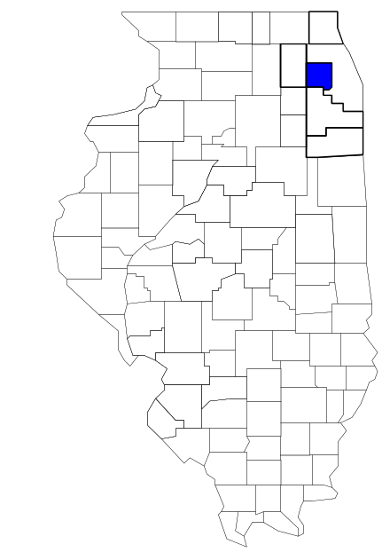DuPage County

Metropolitan Enforcement Group

Prepared by

The Research and Analysis Unit of the
Illinois Criminal Justice Information Authority

George H. Ryan, Governor
Peter B. Bensinger, Chairman
Candice M. Kane, Executive Director

March 2001



ILLINOIS
CRIMINAL JUSTICE
INFORMATION AUTHORITY

This project was supported by Grant # 99-DB-BX-0017, awarded to the Illinois Criminal Justice Information Authority by the Bureau of Justice Assistance, Office of Justice Programs, U.S. Department of Justice. The Assistant Attorney General, Office of Justice Programs, coordinates the activities of the following programs, offices and bureaus: Bureau of Justice Assistance, Bureau of Justice Statistics, National Institute of Justice, Office of Juvenile Justice and Delinquency Prevention, and the Office for Victims of Crime. Points of view or opinions contained within this document are those of the authors and do not necessarily represent the official position or policies of the U.S. Department of Justice.

Illinois Criminal Justice Information Authority
120 S. Riverside Plaza, Suite 1016
Chicago, Illinois 60606-3997
Telephone (312) 793-8550
Telefax (312) 793-8422
TDD: (312) 793-4170
World Wide Website http://www.icjia.state.il.us
ACKNOWLEDGMENTS

A number of organizations and individuals put a great deal of effort into the development of this document. The Authority’s Research and Analysis Unit is very grateful for the assistance provided by the following organizations:

Administrative Office of the Illinois Courts
Illinois Department of Human Services’ Office of Alcoholism and Substance Abuse
Illinois Department of Children and Family Services
Illinois Department of Corrections
Illinois State Police
DuPage County Metropolitan Enforcement Group
U.S. Bureau of the Census

In addition, the following individuals were instrumental in gathering, interpreting and presenting these data:

Sharyn Adams

Megan Alderden

Robert Bauer

Alissa Clark

John Condne

Karen Griffiths

Tracy Hahn

Jennifer Hiselman

David Katz

Joseph Kozenczak

Gary Kupsak

Erica Morrow

David Olson

Adrianna Perez

Gerard Ramker

Robert Taylor

CONTENTS

Section Page Number

EXECUTIVE SUMMARY

I. Introduction 1
II. Trends in Violent Index Offenses and Arrests 3
III. Trends in Drug Arrests 6
IV. Trends in Drug Seizures 14
V. Trends in Prosecutions for Drug Offenses 16
VI. Trends in Percent of Convicted Drug Offenders Sentenced to Prison 18
VII. Trends in Drug Treatment Admissions in DuPage County, by Drug Type 23
VIII. Trends in Drug Exposed Births 26
IX. Summary of Drug Situation 27
X. Appendices 30
Map 1 1999 Percent of Illinois' County-level Population Covered by an
Authority-funded Multi-jurisdictional Enforcement Group or Task Force 31
Map 2 1999 Illinois Cannabis Seizure Rates, by County 32
Map 3 1999 Illinois Controlled Substances Seizure Rates, by County 33
Map 4 1999 Illinois Methamphetamine Seizure Rates, by County 34
XI. Bibliography 35

LIST OF FIGURES

Figure Page Number Page Number

Figure 1. Violent Index Offense Rates for Participating and Non-participating Agencies in Region Covered by DUMEG 3
Figure 2. 1999 Violent Index Offenses* Reported by Participating and Non-participating Agencies in Region Covered by DUMEG 4
Figure 3. Violent Index Arrest Rates for Participating and Non-participating Agencies in Region Covered by DUMEG 5
Figure 4. 1999 Violent Index Arrests* Reported by Participating and Non-participating Agencies in Region Covered by DUMEG 5
Figure 5. Total Drug Arrest Rates for DUMEG and Participating and Non-participating Agencies in Region Covered by DUMEG 7
Figure 6. 1999 Drug Arrests* Reported by Participating and Non-participating Agencies in Region Covered by DUMEG 7
Figure 7. Total 1999 Drug Arrests* Reported by Participating and Non-participating Agencies in Region Covered by DUMEG, by Drug Type 8
Figure 8. Drug Arrests by DUMEG 9
Figure 9. Percent of Total Drug Arrests Accounted for by DUMEG 9
Figure 10. Cannabis Arrests Rates in DuPage County as Reported by Participating Agencies, Non-participating Agencies and DUMEG 10
Figure 11. Percent of Cannabis Arrests Accounted for by DUMEG
11
Figure 12. Controlled Substances Arrest Rates in DuPage County as Reported by Participating Agencies, Non-participating Agencies and DUMEG 12
Figure 13. Percent of Controlled Substances Arrests Accounted for by DUMEG 12
Figure 14. DUMEG Drug Arrests for Possession versus Delivery, by Drug Type 13
Figure 15. Cannabis Seized and Submitted by DuPage County and Seized by DUMEG 14
Figure 16. Powder and Crack Cocaine Seized and Submitted by DuPage County and Seized by DUMEG 15
Figure 17. Number of Felony Filings in DuPage County 16
Figure 18. Total DUMEG Drug Arrests and Percentage of Arrests Resulting in Prosecution 17
Figure 19. Sentences Imposed on Felons Convicted in DuPage County
18
Figure 20. Sentences Imposed on Convicted DUMEG Drug Offenders 19
Figure 21. Number of Drug Offenders Committed to IDOC by DuPage County and DUMEG 20
Figure 22. Drug Offenders as a Percent of Total IDOC Commitments from DuPage County 21
Figure 23. Drug Offenders Committed to IDOC from DuPage County, by Offense Class 22
Figure 24. Substance Abuse Treatment Admissions from DuPage County 23
Figure 25. Comparison of Drug Arrests by DUMEG and Participating and Non-participating Agencies vs. Drug Abuse Treatment Admissions in DuPage County, 1999 25
Figure 26. Cases of Drug-Exposed Infants in DuPage County 26
Figure 27. Availability of Drugs in Illinois, 1998 27
Figure 28. Price Per Gram in Illinois, 1998 28

EXECUTIVE SUMMARY

Since 1989, the Authority’s Research and Analysis Unit has received funds under the federal Anti-Drug Abuse Act of 1988 to document the extent and nature of drug and violent crime in Illinois and the criminal justice system’s response to these offenses. As a result of these efforts, the Authority has amassed a large amount of data measuring the extent and nature of drug and violent crime in Illinois and the impact these crimes have had on the criminal justice system. In addition, as part of its monitoring and evaluation efforts, the Authority also requires funded programs to submit monthly data reports describing their activities and accomplishments. This profile is intended to provide a general overview of the drug and violent crime problem in the jurisdictions covered by Illinois’ MEGs and task forces, and the response to these problems by the units.

Although the data presented in this report are by no means inclusive of all indicators, they do provide a general overview of drug and violent crime and the response and impact of the criminal justice system. The following represent general conclusions that can be made based on the data analyzed for this report.

- In 1999, 30 local Illinois police agencies participated in DUMEG (a participating agency is defined as one that contributes either personnel or financial resources to DUMEG). Officers assigned to DUMEG (totaling 13 in 1999, ten from participating agencies) accounted for less than one percent of the total number of sworn police officers working for agencies participating in DUMEG.

- The violent Index offense rate was collectively higher across the jurisdictions that participated in DUMEG than it was among the combined jurisdictions that did not participate in DUMEG. However, the violent Index offense rate has steadily decreased since 1994 in those agencies that participated in DUMEG, while increasing in the area covered by the two agencies not participating in DUMEG; thus, reducing the difference between the violent Index offense rate achieved by participating agencies and the violence Index offense rate achieved by non-participating agencies (page 3).

- The drug arrest rate tended to be slightly higher in the jurisdictions that participated in DUMEG than in those jurisdictions that did not participate in DUMEG, for most of the years analyzed. The drug arrest rate achieved by DUMEG was dramatically lower than the rates experienced by both the participating and non-participating agencies (page 6).

- When comparing the types of drug offenders arrested by those agencies participating in DUMEG, those agencies not participating and DUMEG, it was found that DUMEG tended to target and arrest more serious drug law violators, specifically violators of the Controlled Substances Act, which tend to be felony-level offenses. However, the proportion accounted for by arrests for violations of the Controlled Substances Act decreased across all jurisdictions, including the arrests made by DUMEG (page 8).

- The majority of all drug arrests reported by DUMEG, for either violations of the Cannabis Control Act or the Controlled Substances Act, involve drug sale or delivery (page 13).

- Between 1993 and 1999, cannabis seizures by DUMEG decreased 24 percent, while cocaine seizures decreased 85 percent (pages 14 and 15).

- Between 1991 and 1999, 98 percent of all drug arrests by DUMEG resulted in prosecution. Of these DUMEG drug offender prosecutions, 70 percent were for violations of the Controlled Substance Act. In addition, between 1989 and 1999, 68 percent of drug offenders who were prosecuted as a result of DUMEG activity were convicted (page 17).

- In 1999, among those DUMEG drug offenders convicted and sentenced, prison sentences accounted for the largest proportion (39 percent), followed by jail sentences (33 percent) and probation sentences (28 percent) (page 19).

- Between 1989 and 1999, prison sentences resulting from DUMEG cases accounted for one-quarter of all drug-law violators sent to prison from the region where DUMEG operates (page 20).

- Unlike the arrests made by participating and non-participating agencies, the arrests made by DUMEG tended to involve the substances considered to be most serious (i.e., felony versus misdemeanor) and the substances for which a large proportion of community residents were seeking and receiving substance abuse treatment (page 24).

I. Introduction

The DuPage County Metropolitan Enforcement Group (DUMEG) covers DuPage County, which had a 1999 total population of 859,399 – 7 percent more than in 1990. In 1999, thirty local police agencies participated in DUMEG. As a result, these agencies served nearly the entire (99 percent) population in DuPage County covered by DUMEG (see Map 1 on page 30). A participating agency is defined as one that contributes either personnel or financial resources to DUMEG.

In addition to agencies that participate in DUMEG, DuPage County is also served by two additional police departments, Roselle and Wayne, that do not participate in DUMEG. According to the Illinois State Police, the county sheriff and local police departments in DuPage County, combined, employed 1,742 full-time police officers as of Oct. 31, 1999. In comparison, there were a total of 13 officers assigned to DUMEG in 1999, ten of which were assigned by participating agencies, two from the Illinois State Police (ISP) and one from the DuPage County State's Attorney's Office. Thus, the officers assigned to DUMEG during 1999 accounted for a relatively small proportion—less than 1 percent—of the total number of sworn police officers working in the participating police departments, and the region as a whole.

Since 1989, the Authority’s Research and Analysis Unit has received funds under the federal Anti-Drug Abuse Act of 1988 to document the extent and nature of drug and violent crime in Illinois and the criminal justice system’s response to these offenses. As a result of these efforts, the Authority has amassed a large amount of data measuring the extent and nature of drug and violent crime in Illinois and the impact these crimes have had on the criminal justice system. In addition, as part of its monitoring and evaluation efforts, the Authority also requires funded programs to submit monthly or quarterly data reports describing their activities and accomplishments. To put this information into the hands of Metropolitan Enforcement Group (MEG) and drug task force directors and policy board members, the Authority’s Research and Analysis Unit has developed profiles – of which this is one – for each MEG and task force. The profile is intended to provide a general overview of the drug and violent crime problem in the jurisdictions covered by Illinois’ MEGs and task forces, and the response to these problems by the units.

In addition to administering federal block-grant funds that come to Illinois for crime control initiatives, the Illinois Criminal Justice Information Authority is also responsible for providing policymakers, criminal justice professionals and others with information, tools and technology needed to make effective decisions that improve the quality of criminal justice in Illinois. The Authority provides an objective system-wide forum for identifying critical problems in criminal justice, developing coordinated and cost-effective strategies, and implementing and evaluating solutions to those problems. The specific powers and duties of the Authority are delineated in the Illinois Criminal Justice Information Act (Illinois Compiled Statutes, Ch. 20, Sec. 3930). Two of the Authority’s many responsibilities are serving as a clearinghouse of information and research on criminal justice and undertaking research studies to improve the administration of criminal justice.

While the data presented in this report are by no means inclusive of all indicators, they do provide a general overview of drug and violent crime and the response and impact of the criminal justice system. In addition, these data are readily available and consistently defined through existing statewide data collection mechanisms. Some data presented in this profile have been analyzed differently than in previous years; therefore, caution must be taken when comparing numbers presented with previous profiles.
While a considerable amount of the information presented in this profile has been provided to the Authority by DUMEG, a number of state agencies have also provided data to the Authority that are included in this report. Specifically, the Illinois State Police, the Administrative Office of the Illinois Courts, the Illinois Department of Human Services’ Office of Alcoholism and Substance Abuse, the Illinois Department of Corrections and the Illinois Department of Children and Family Services all provided data used to develop this profile. The support and cooperation of these agencies and their staffs have helped make this report an informative and timely source of information on the activities of the criminal justice system in Illinois.

- Trends in Violent Index Offenses and Arrests

While most of Illinois’ Metropolitan Enforcement Groups and drug task forces are primarily involved in drug enforcement activities, it is clear that the relationship between drugs and violence is particularly evident in a number of Illinois communities. In addition, a number of MEGs and task forces have increased their involvement in the investigation of violent crime, particularly that associated with gang activity and violence related to drug distribution, sale and turf battles. One of the most commonly used indicators of the level of crime in a particular jurisdiction is the number of Index offenses reported to the police. In Illinois, as part of the Illinois Uniform Crime Reporting (I-UCR) program, every law enforcement agency in the state is required to report crime data monthly to the Illinois State Police. There are eight separate offenses that constitute the Crime Index, including murder, criminal sexual assault, robbery, aggravated assault (violent Index offenses), burglary, theft, motor vehicle theft and arson (property Index offenses). Although these eight offenses do not account for all crimes reported to the police, they are considered to be the most serious, frequent, pervasive and consistently defined by different law enforcement agencies.

In 1999, the total number of violent Index offenses reported to the police in the region where DUMEG operates totaled 1,040, a 46 percent decrease from the 1,931 offenses reported in 1993. The majority (80 percent) of violent Index offenses reported to the police between 1993 and 1999 were aggravated assaults, while 11 percent were robberies.

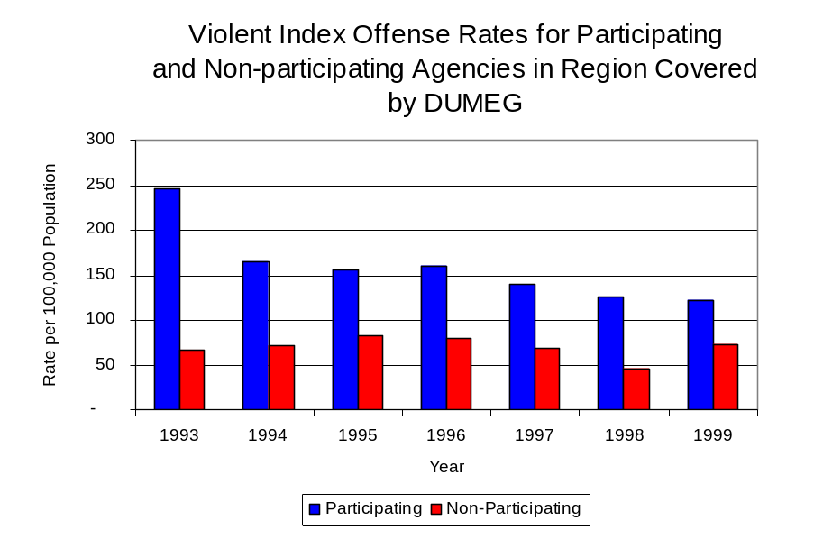
During the period analyzed, the violent Index offense rate for DuPage County decreased 50 percent, from 241 offenses per 100,000 population in 1993 to 121 offenses per 100,000 population in 1999. Similarly, the violent Index offense rate in the participating agencies decreased 50 percent, from 247 to 123 offenses per 100,000 population, while the rate in the non-participating agencies increased 8 percent, from 67 to 73 offenses per 100,000 population (Figure 1). Thus, while the violent Index offense rate was collectively higher across the jurisdictions that participate in DUMEG than it was among the combined jurisdictions that did not participate in DUMEG, the violent Index offense rate has steadily decreased over the past six years in those agencies that participate in DUMEG, while increasing in those agencies that do not participate in DUMEG, and the difference has become even more dramatic over the past eight years.
Source: ICJIA calculations using
Illinois State Police and U.S. Census Bureau data
Figure 1

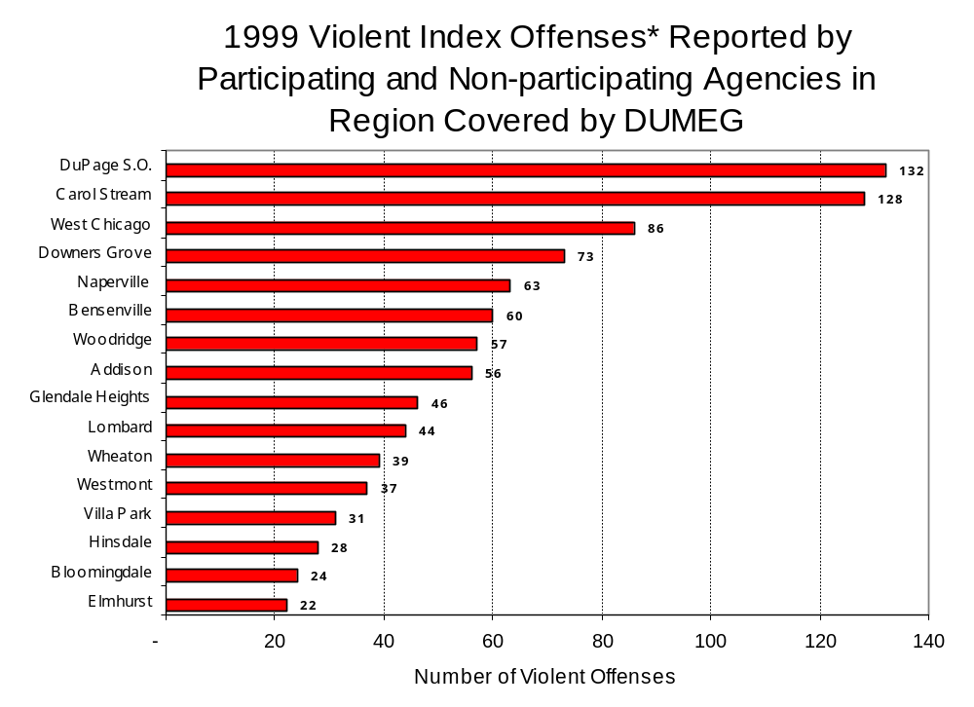
Across the 32 individual local law enforcement agencies covered by DUMEG’s jurisdiction, two agencies, the DuPage County Sheriff's Office and the Carol Stream Police Department, accounted for one-quarter of all violent offenses reported to the police (Figure 2). Sixteen agencies had fewer than twenty violent offenses reported in 1999 and are excluded from Figure 2. When controlling for differences in the populations served by these law enforcement agencies, the violent Index offense rate ranged from ten violent Index offenses per 100,000 population in Winfield to 339 offenses per 100,000 population in Carol Stream.
Source: Illinois State Police *Agencies reporting 20 or more violent offenses
Figure 2

An indicator of the workload that law enforcement agencies place on other components of the justice system is the number of arrests made by police, including those for violent and property Index offenses and drug offenses. Unlike offenses, which are what police must respond to, arrests represent those offenders who may eventually be processed through other components of the justice system, including the courts, county jails, and state and local correctional programs.

Between 1993 and 1999, the number of arrests for violent Index offenses made by law enforcement agencies in DuPage County decreased 38 percent, from 824 to 508. As with reported violent Index offenses, the majority (83 percent) of violent Index arrests were for aggravated assaults, followed by robberies (13 percent).

During the period analyzed, the violent Index arrest rate for DuPage County decreased 42 percent, from 104 offenses per 100,000 population in 1993 to 60 arrests per 100,000 population in 1999. Similarly, the violent Index arrest rate in the participating agencies decreased 43 percent, from 106 to 61 offenses per 100,000 population, while the rate in the non-participating agencies increased 14 percent, from 34 to 38 offenses per 100,000 population (Figure 3).

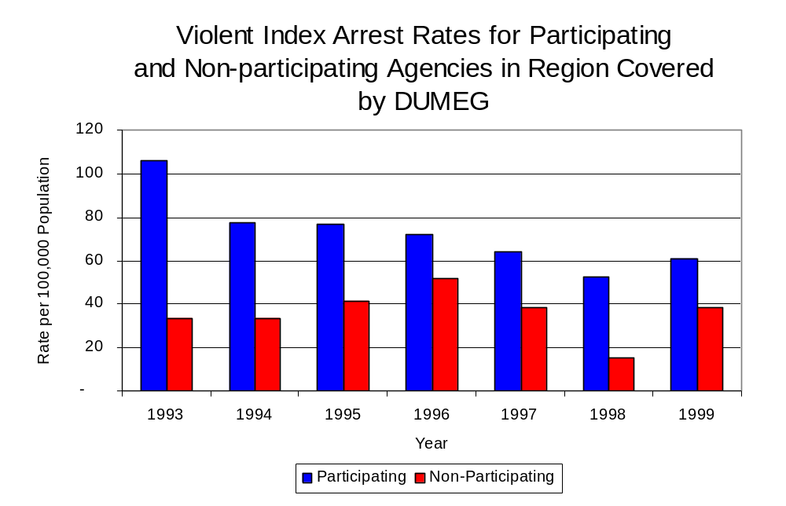
Similar to the number of violent Index offenses, the majority (56 percent) of arrests for violent Index offenses occurring in DuPage County were made by seven agencies. One-half (16) agencies had fewer than ten arrests for violent Index offenses reported in 1999 and are excluded from Figure 4. Of the 518 violent Index arrests made in 1999, the DuPage County Sheriff's Office accounted for the largest proportion (14 percent), followed by Carol Stream (9 percent) and Downers Grove, Glendale Heights, Woodridge, Addison and Naperville (each accounting for 7 percent) (Figure 4).
Figure 3
Source: ICJIA calculations using
Illinois State Police and U. S. Census Bureau data

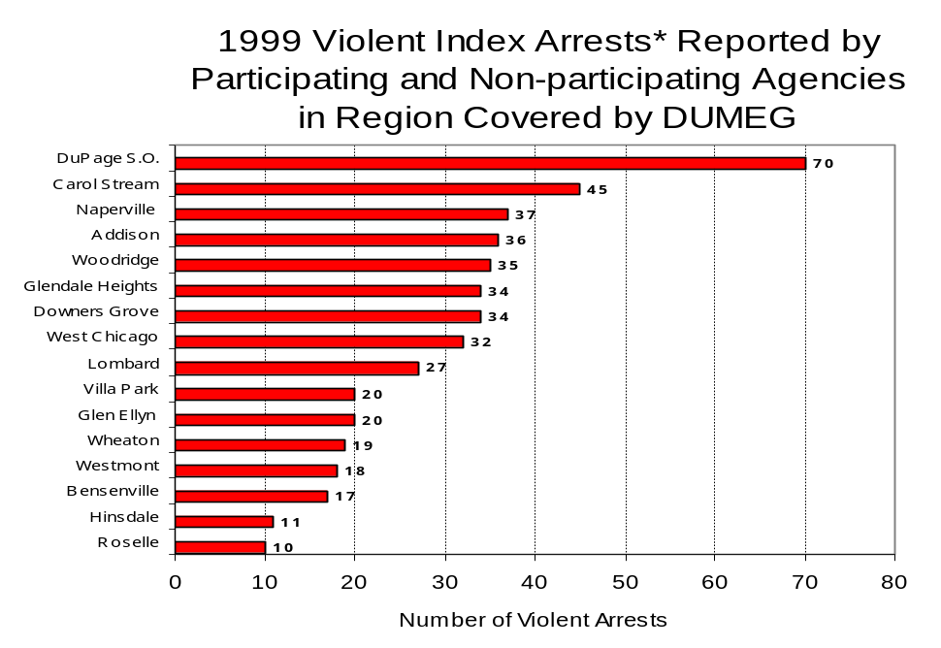
Figure 4
Source: Illinois State Police *Agencies reporting ten
or more violent offenses
III. Trends in Drug Arrests

There are two sources of drug arrest data presented in this section. One source is the Illinois Uniform Crime Reporting (I-UCR) program that includes information submitted by local law enforcement agencies on the number of persons arrested for violations of Illinois’ Cannabis Control Act, Controlled Substances Act, Hypodermic Syringes and Needles Act, and Drug Paraphernalia Control Act. In addition, data on drug arrests made by Illinois’ MEGs and task forces are reported to the Illinois Criminal Justice Information Authority. In some jurisdictions, arrests made by the MEG or task force may be reported by both local law enforcement agencies through the I-UCR and to the Authority by the unit. In other jurisdictions, arrests made by the MEG or task force are only reported to the Authority by the unit. Therefore, in some instances drug arrests may be double counted – included in both local agency statistics reported to I-UCR and those of the MEG or task force. Currently there is no mechanism in place to ensure that drug arrest statistics are not being duplicated at both the local agency and MEG/task force level. This should be kept in mind when interpreting the information presented in the following section.

The majority of drug offenses in Illinois are violations of either the Cannabis Control Act – which prohibits the possession, sale and cultivation of marijuana – or the Controlled Substances Act – which prohibits the possession, sale, distribution or manufacture of all other illegal drugs, such as cocaine and opiates. Illinois also has various other laws prohibiting other drug-related activity. These include the Hypodermic Syringes and Needles Act – which prohibits the possession or sale of hypodermic instruments – and the Drug Paraphernalia Control Act – which prohibits the possession, sale or delivery of drug paraphernalia. In general, violations of Illinois Controlled Substances Act are considered to be more serious, since they primarily involve cocaine, heroin, methamphetamine, and hallucinogens, and are almost all classified under Illinois law as felonies. The majority of cannabis and drug paraphernalia offenses encountered by police, on the other hand, tend to be misdemeanor-level offenses.

In 1999, local law enforcement agencies in the counties covered by DUMEG reported 3,272 arrests for drug law violations, nearly double the number in 1993 (1,553 arrests). Between 1993 and 1999, arrests for violations of Illinois’ Cannabis Control Act consistently out-numbered arrests for violations of the Controlled Substances Act in DuPage County. During the same period, the number of arrests for violations of the Cannabis Control Act in DuPage County increased 67 percent, from 1,125 to 1,882, while arrests for violations of the Controlled Substances Act increased 23 percent, from 345 to 423. In addition, arrests for violations of the Drug Paraphernalia Control Act, enacted in 1993, increased dramatically from 61 in 1993 to 897 in 1999. Much of this increase can be attributed to a 1994 addition to the Drug Paraphernalia Control Act, which included the possession of drug paraphernalia as a violation.

Because arrests for violations of the Drug Paraphernalia Control Act are frequently made in conjunction with other drug offense arrests, these arrests may be double-counted, thus skewing the actual number of drug arrests. Therefore, only arrests for violations of the Cannabis Control Act and Controlled Substances Act will be used for drug arrest comparisons between DUMEG and the participating and non-participating agencies.

During the period analyzed, the drug arrest rate for the Cannabis Control and Controlled Substances Acts, combined, in DuPage County increased 46 percent, from 184 arrests per 100,000 population in 1993 to 268 arrests per 100,000 population in 1999. The drug arrest rate in the participating agencies increased 47 percent, from 184 to 270 arrests per 100,000 population, while the drug arrest rate in the non-participating agencies increased 25 percent, from 180 to 226 arrests per 100,000 population. The arrest rate for DUMEG increased 51 percent, from 11 to 17 arrests per 100,000 population (Figure 5). Thus, the drug arrest rate tended to be slightly higher collectively in the jurisdictions that participated in DUMEG than in those jurisdictions that did not participate in DUMEG, while the drug arrest rate achieved by DUMEG was dramatically lower than the rates experienced by both the participating and non-participating agencies.
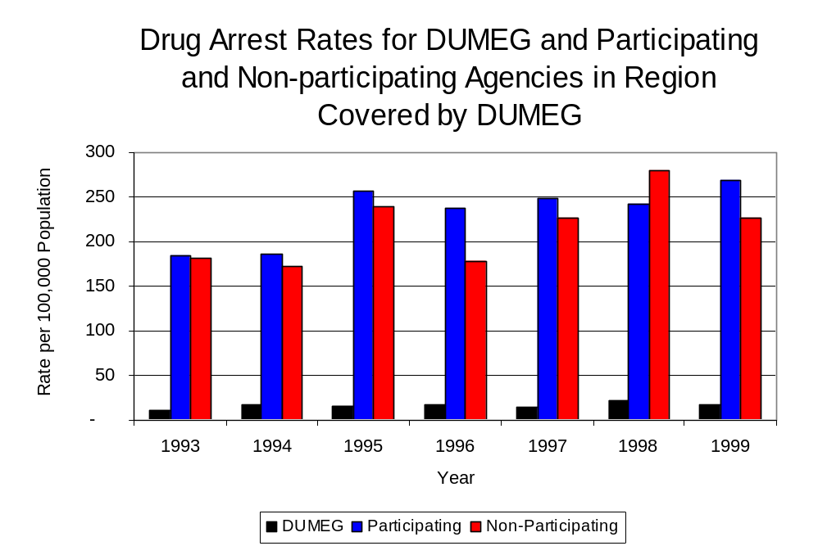
Source: ICJIA calculations using Illinois State Police and U.S. Census Bureau data
Figure 5

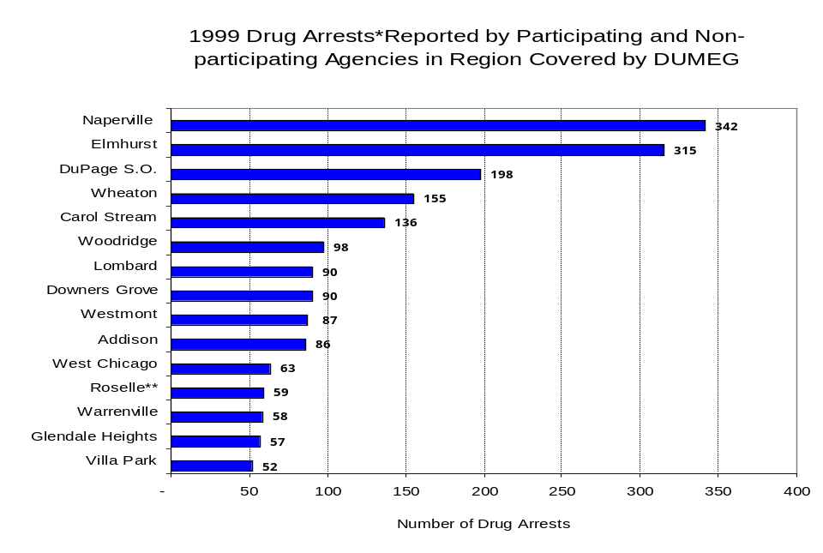
Across the individual local law enforcement agencies in the region covered by DUMEG, the total number of cannabis and controlled substances arrests ranged from zero to 342. Of the 2,305 drug arrests made during 1999 in DuPage County, five agencies accounted for one-half of these drug arrests. Seventeen agencies had fewer than 50 drug arrests reported in 1999 and are excluded from Figure 6. Naperville accounted for the largest proportion (15 percent) of cannabis and controlled substance arrests in DuPage County, followed by Elmhurst (14 percent), the DuPage County Sheriff’s Office (9 percent), Wheaton (7 percent) and Carol Stream (6 percent) (Figure 6). Among the 15 agencies with the highest number of drug arrests during 1999, all but one participated in DUMEG.
Figure 6
Source: Illinois State Police *Agencies reporting 50 or more drug arrests
**Agency does not participate in DUMEG

In addition to the dramatic difference in the number of drug arrests made, there are also
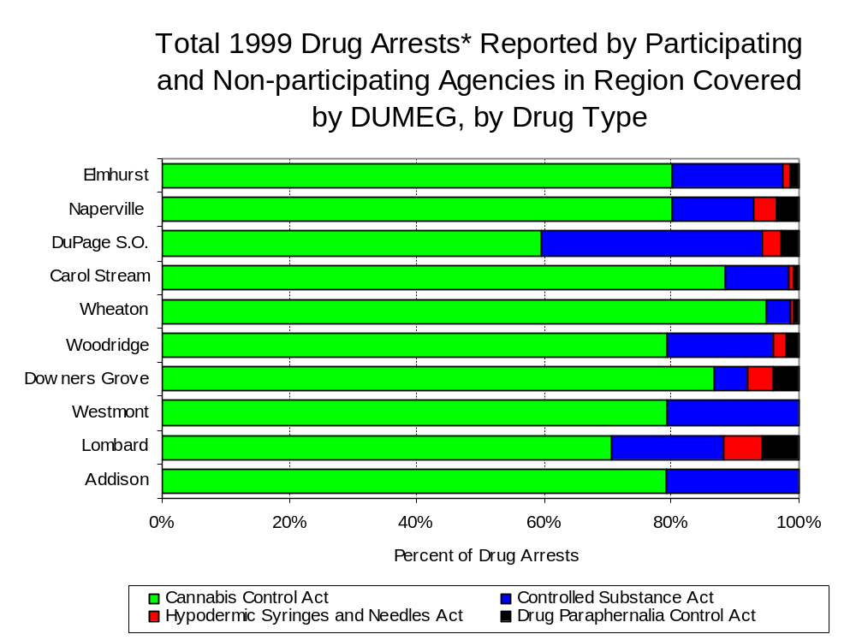
differences in the types of drug law violation arrests across the agencies in the region. In 1999, violations of the Cannabis Control Act accounted for the largest proportion of arrests across most individual agencies in DuPage County (Figure 7).
Figure 7
Source: Illinois State Police *Agencies reporting 100 or more drug arrests

Between 1993 and 1999, the number of combined cannabis and controlled substances arrests made by DUMEG increased 42 percent, from 99 to 141 (Figure 8). Unlike drug arrests made by most local police departments in the region, violations of the Controlled Substances Act accounted for the majority of drug arrests made by DUMEG throughout most of the period analyzed. During the period analyzed, the number of DUMEG arrests for violations of the Cannabis Control Act increased nearly five-fold, from eight to 47, while arrests for violations of the Controlled Substances Act increased 3 percent, from 91 to 94 (Figure 8).

Between 1993 and 1999, the proportion of drug arrests accounted for by violations of the Controlled Substances Act decreased for participating and non-participating agencies as well as DUMEG. In 1999, 62 percent of the drug arrests made by DUMEG were for violations of the Controlled Substances Act, compared to 60 percent in 1993. Similarly, in 1999, arrests for controlled substances violations accounted for 19 percent of the drug arrests made in the participating agencies and 5 percent for the non-participating agencies, compared to 24 percent and 16 percent, respectively, in 1993. Thus, arrests by DUMEG were more likely than arrests by either participating or non-participating agencies to involve violations of Illinois’ Controlled Substances Act, as opposed to the Cannabis Control Act. One interpretation of this pattern is that DUMEG is more focused in who they are targeting and arresting than local departments, and are also getting a more serious drug law violator, since violations of the Controlled Substances Act are more likely to involve felony-level offenses.

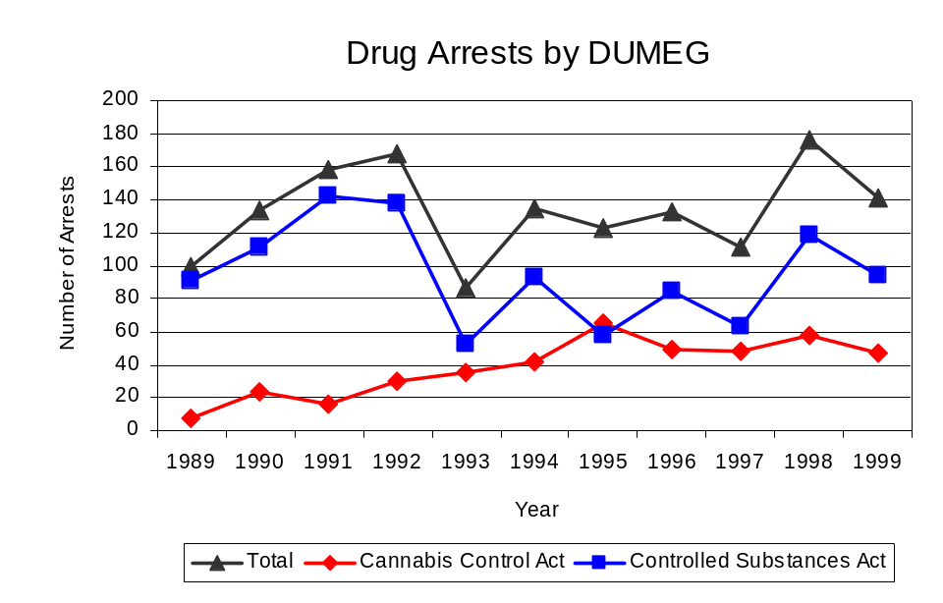
Source: DUMEG
Figure 8
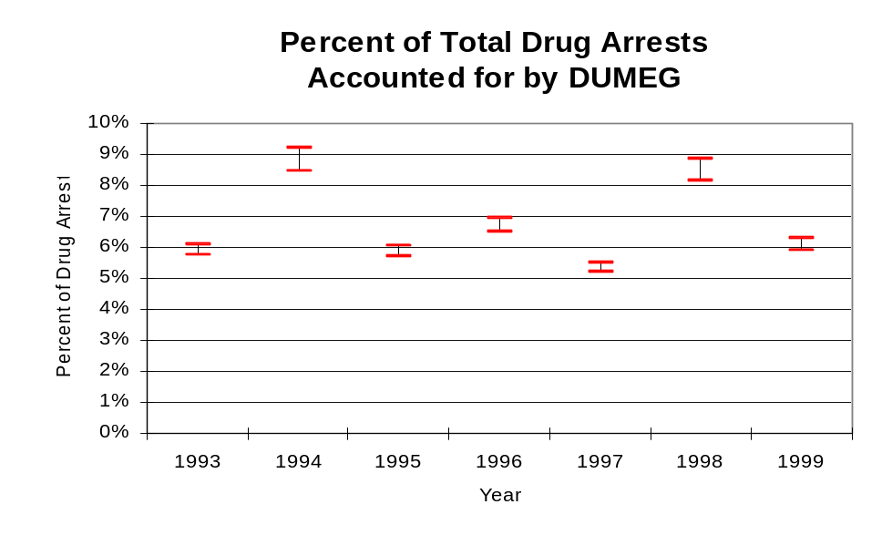
The data presented below represent the percent of total drug arrests made by agencies participating in DUMEG accounted for by DUMEG. An upper and lower bound is shown in Figure 9 which accounts for whether or not the units numbers are counted as part of the UCR submissions made by local departments (which is unknown at this point). The upper bound indicates the percentage of arrests if all of the DUMEG arrests are included in the local UCR submissions. The lower bound indicates the percentage if none of the DUMEG arrests are included in the local UCR submissions. It is estimated that the proportion of all drug arrests across participating agencies accounted for by DUMEG remained relatively stable between 1993 and 1999 accounting for approximately 6 percent in both years. Thus, as a result of the fact that the officers assigned to DUMEG accounted for a small proportion of total officers in the region, and unlike many other units, they accounted for a relatively small proportion of the drug arrests in the region.
Figure 9
Source: ICJIA calculations using
Illinois State Police and DUMEG data

The number of arrests for violations of Illinois’ Cannabis Control Act in DuPage County totaled 1,882 in 1999, 67 percent more than the 1,125 arrests made for cannabis violations in 1993. Between 1993 and 1999, the proportion of all drug arrests accounted for by violations of the Cannabis Control Act in DuPage County increased during the period, increasing from 77 percent to 82 percent. Agencies participating in DUMEG accounted for the largest portion (97 percent) of the total number of arrests for cannabis violations. DUMEG reported a total of 47 arrests for cannabis violations in 1999, accounting for one-third of the unit's drug arrests.

Between 1993 and 1999, the cannabis arrest rate increased 56 percent both for DuPage County and the participating agencies, increasing from 141 to 219 arrests per 100,000 population and 140 to 219 arrests per 100,000 population, respectively. The cannabis arrest rate in the non-participating agencies increased 42 percent, from 151 to 215 arrests per 100,000 population. The cannabis arrest rate for DUMEG, on the other hand, increased slightly, from five to six arrests per 100,000 population, while accounting for a decreased percentage of total drug arrests, from 40 percent in 1993 to 33 percent in 1999 (Figure 10).
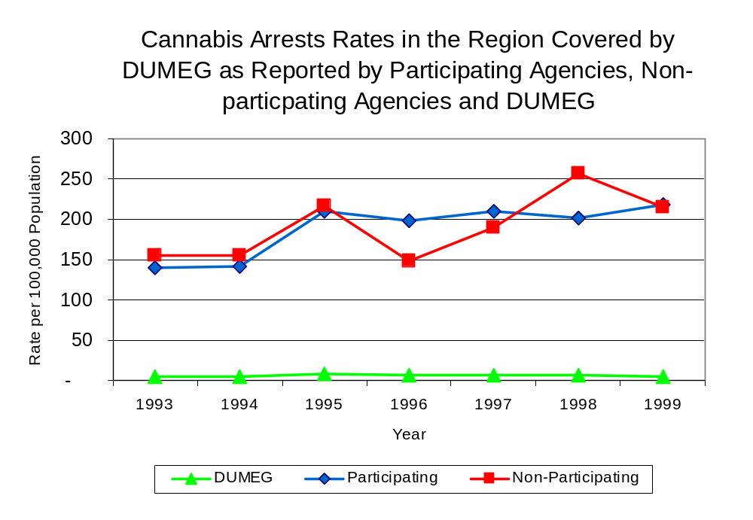
Thus, the arrest rate for violations of the Cannabis Control Act was collectively slightly higher in the area served by participating agencies than in the combined jurisdictions of the non-participating agencies.
Source: ICJIA calculations using
Illinois State Police and DUMEG data
Figure 10

The data presented in Figure 11 represent the percent of cannabis arrests made by agencies participating in DUMEG accounted for by DUMEG. An upper and lower bound is shown which accounts for whether or not the unit’s numbers are counted as part of the UCR submissions made by local departments (which is unknown at this point). The upper bound indicates the percentage of arrests if all of the DUMEG arrests are included in the local UCR submissions. The lower bound indicates the percentage if none of the DUMEG arrests are included in the local UCR submissions. It is estimated that the proportion of cannabis arrests across participating agencies accounted for by DUMEG was relatively stable throughout the period analyzed, accounting for approximately 3 percent in 1993, but decreasing slightly to between 2 and 3 percent in 1999.

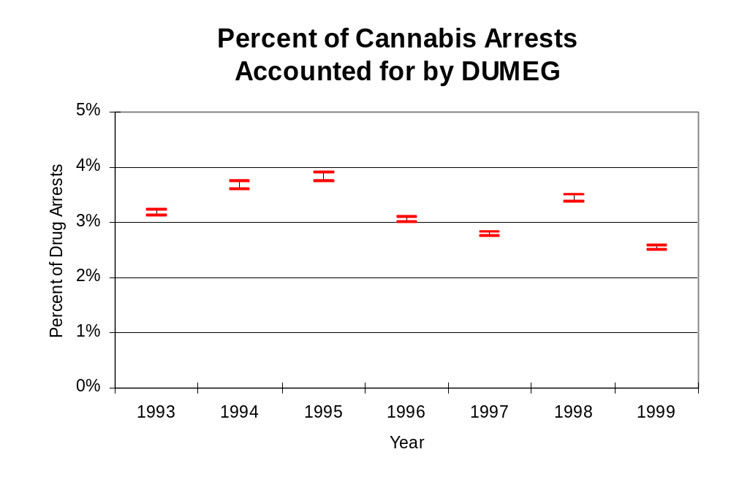
Figure 11
Source: ICJIA calculations using
Illinois State Police and DUMEG data
In DuPage County, the number of arrests for violations of Illinois’ Controlled Substances Act increased 23 percent between 1993 and 1999, from 345 to 423. Between 1993 and 1999, the proportion of all drug arrests accounted for by violations of the Controlled Substances Act in DuPage County decreased from 23 percent to 18 percent. Agencies participating in DUMEG accounted for the largest portion (99 percent) of the total number of arrests for controlled substances violations. In 1999, DUMEG reported 94 arrests for controlled substance violations, accounting for two-thirds of all drug arrests reported to the Authority by the unit.

Between 1993 and 1999, the arrest rate for controlled substances act violations for DuPage County increased 14 percent, from 43 to 49 arrests per 100,000 population (Figure 12). The controlled substances arrest rate in the participating agencies increased 16 percent, from 43 arrests per 100,000 population in 1993 to 50 arrests per 100,000 population in 1999, while the arrest rate in the non-participating agencies decreased 62 percent, from 30 to 12 arrests per 100,000 population during the same period. The controlled substances arrest rate for DUMEG increased 69 percent, from 7 to 11 arrests per 100,000 population (Figure 12). Thus, the Controlled Substances Act arrest rate was higher in the participating agencies than the non-participating agencies.

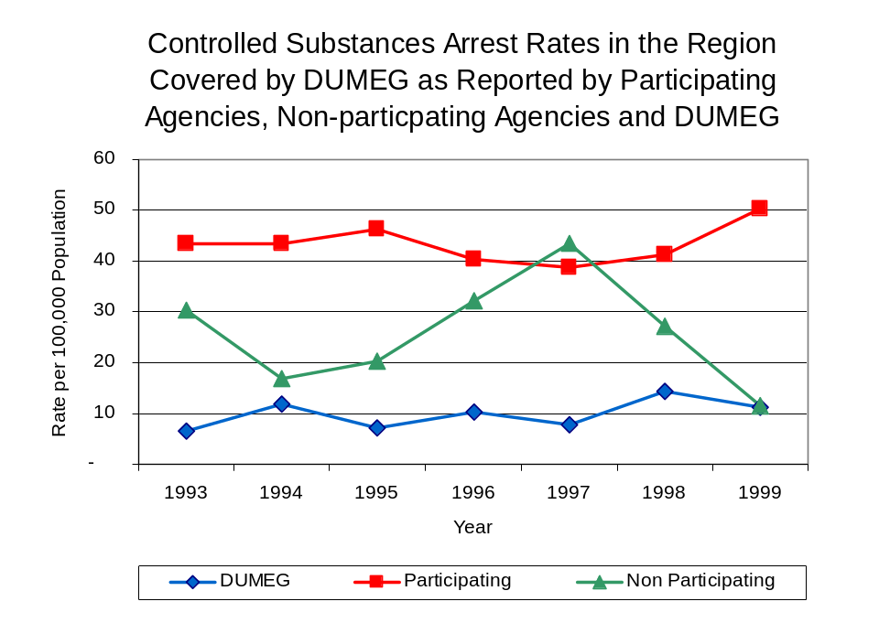
Figure 12
Source: ICJIA calculations using Illinois State Police and DUMEG data
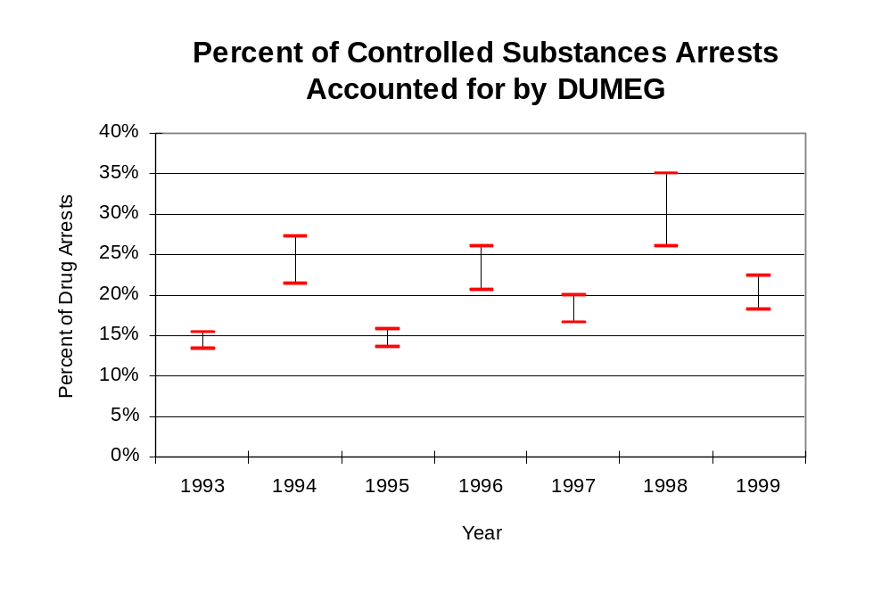
The data presented in Figure 13 represent the percent of controlled substances arrests made by agencies participating in DUMEG accounted for by DUMEG. An upper and lower bound is shown which accounts for whether or not the units numbers are counted as part of the UCR submissions made by local departments (which is unknown at this point). The upper bound indicates the percentage of arrests if all of the DUMEG arrests are included in the local UCR submissions. The lower bound indicates the percentage if none of the DUMEG arrests are included in the local UCR submissions. It is estimated that the proportion of controlled substances arrests across participating agencies accounted for by DUMEG was between 13 to 15 percent in 1993, and increased to between 18 to 22 percent in 1999.
Figure 13
Source: ICJIA calculations using Illinois State Police and DUMEG data

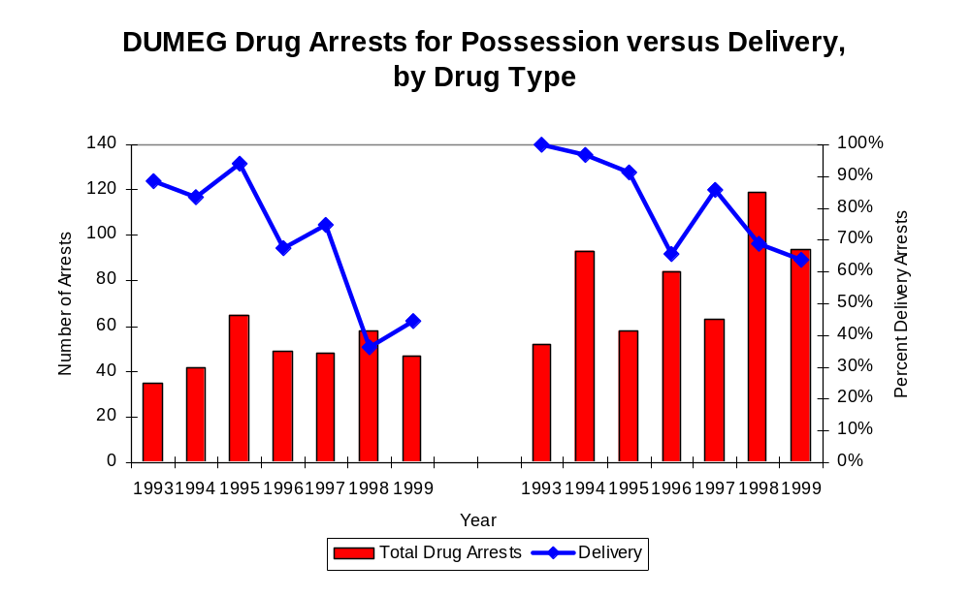
The majority of all drug arrests reported by DUMEG are for delivery. Between 1993 and 1999, the number of drug delivery arrests made by DUMEG decreased slightly (2 percent), from 83 to 81. Arrests for drug delivery accounted for three-quarters of all drug arrests made by DUMEG between 1993 and 1999. When cannabis and controlled substance arrests were examined separately, during the period analyzed, arrests for delivery of controlled substances accounted for 79 percent of the total number of arrests made for violations of the Controlled Substance Act, whereas, arrests for the delivery of cannabis accounted for 69 percent of all arrests for violations of the Cannabis Act.
Figure 14
Source: ICJIA calculations using DUMEG data
Cannabis Control Act

Controlled Substances Act

IV. Trends in Drug Seizures

Drugs seized by law enforcement agencies are another indicator of the extent and nature of illegal drug trade in a jurisdiction. When illegal drugs are seized by law enforcement agencies, all or a portion of the total amount seized is submitted to a crime lab for analysis. Most agencies submit drugs to one of the Illinois State Police crime labs. These labs record the quantity of drugs submitted from each county. This section discusses trends in the quantities of illegal drugs seized and submitted to the Illinois State Police and the DuPage County Sheriff's Office Crime Laboratory from local law enforcement agencies in DuPage County as well as the quantities of drugs seized by DUMEG. It is important to note, however, that while DUMEG data report the total quantities of drugs actually seized, local agency data only represent the quantities of seized drugs that are submitted to the Illinois State Police for analysis. County-level cannabis, cocaine and methamphetamine seizure rates for Illinois' 102 counties are provided in maps located in the Appendix of this report.

As in most Illinois jurisdictions, cannabis accounts for the majority of illegal drugs seized in the region covered by DUMEG. The quantity of cannabis seized and submitted by law enforcement agencies in DuPage County decreased 73 percent, from 170,766 grams in 1993 to 46,843 grams in 1999. Despite cannabis seizures of nearly 1.7 million grams and 1.4 million grams in 1995 and 1998, respectively, the quantity of cannabis seized by DUMEG decreased 24 percent between 1993 and 1999, from 375,539 grams to 285,172 grams (Figure 15). In 1999, DUMEG's cannabis seizure rate of 48,325 grams per 100,000 population was nearly nine times the cannabis seizure rate of 5,451 grams per 100,000 population in DuPage County (Map 2).

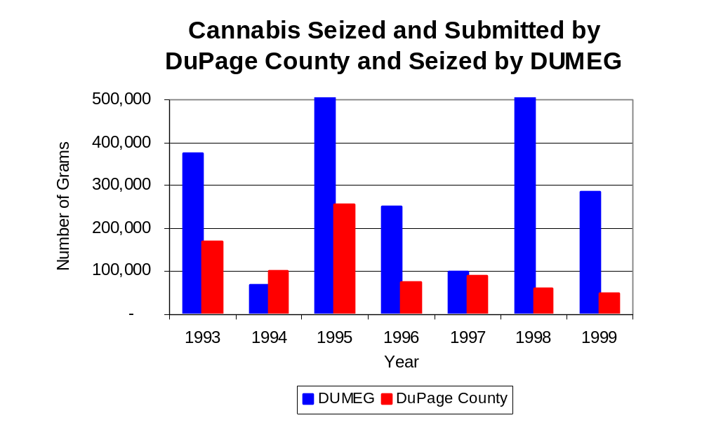
Figure 15
Source: Illinois State Police and DUMEG
Between 1993 and 1999, a combination of crack and powder cocaine has accounted for a small proportion of drugs seized in the region covered by DUMEG. However, the quantity of cocaine seized and submitted by law enforcement agencies in DuPage County decreased 50 percent, from 10,872 grams in 1993 to 5,437 grams in 1999. Between 1993 and 1999, the quantity of cocaine seized by DUMEG decreased 85 percent, from 99,409 grams to 15,021 grams.

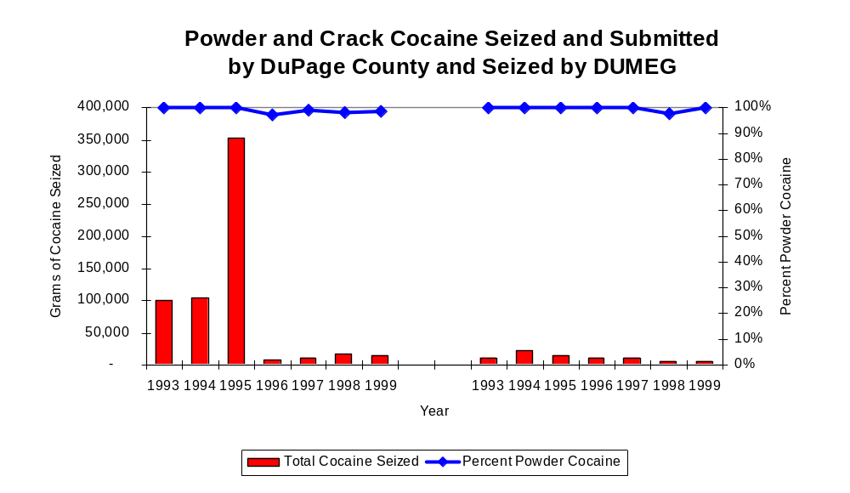
During the period analyzed, powder cocaine accounted for nearly all cocaine seized by DUMEG and the region covered by DUMEG (Figure 16). In 1999, DUMEG's cocaine seizure rate of 1,803 grams per 100,000 population was nearly triple the cocaine seizure rate of 632 grams per 100,000 population in DuPage County (Map 3).
Figure 16
Source: Illinois State Police and DUMEG
DUMEG
DuPage County

The total quantity of illegal drugs seized and submitted by law enforcement agencies in DuPage County decreased 56 percent between 1993 and 1999, from 181,658 grams to 80,570. Similarly, the total quantity of illegal drugs seized by DUMEG has decreased 35 percent, from 476,958 grams in 1993 to 308,046 grams in 1999.

During the period, methamphetamine seizures accounted for a relatively small proportion of total drugs seized by DUMEG. Between 1993 and 1995, there were no reported methamphetamine seizures by law enforcement agencies in DuPage County. However, between 1996 and 1999, nearly 90 grams of methamphetamine were seized and submitted by law enforcement agencies in DuPage County. DUMEG, on the other hand, did not seize any methamphetamine during the entire period. In 1999, DuPage County had a methamphetamine seizure rate of less than three grams per 100,000 population, significantly lower than the statewide seizure rate of 98 grams per 100,000 population, respectively (Map 4).

Trends in Prosecutions for Drug Offenses and All Felonies

Although Illinois has one of the best court reporting systems in the country, the Administrative Office of the Illinois Court only collects information regarding the aggregate number of court filings. Currently, there are no statewide data available on court filings by offense type. The Administrative Office of the Illinois Courts reports data on felony criminal court cases. After screening a case and deciding it warrants further action, the state’s attorney must file formal charges in court. Felony cases can be punished by a probation term up to four years and incarceration for more than one year.

For the majority of the period between 1989 and 1999, the number of felony filings in DuPage County remained relatively stable. The number of felony filings increased 21 percent, during the period analyzed, from 2,623 in 1989 to a period high of 3,186 in 1999 (Figure 17).
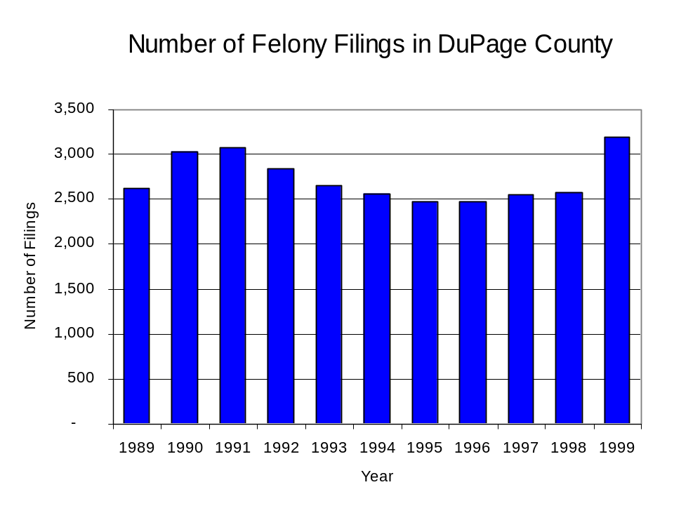
Figure 17
Source: Administrative Office of the Illinois Courts

Between 1989 and 1999, there were 1,441 drug prosecutions initiated as a result of DUMEG arrests in DuPage County. During this time, the number of DUMEG drug arrests increased 42 percent, from 99 arrests in 1989 to 141 arrests in 1999 (Figure 18). Between 1989 and 1999, 98 percent of all drug arrests by DUMEG resulted in prosecution. Seven out of every ten DUMEG drug offender prosecutions during this period were for violations of the Controlled Substance Act. In some years, the proportion of arrests resulting in a prosecution exceeded 100 percent. This is due to some slight differences in the timing of an arrest and the filings of charges, or could be due to charges, rather than defendants, being reported by the unit. In addition, some offenders have charges filed, and a subsequent warrant issued, without an arrest taking place.

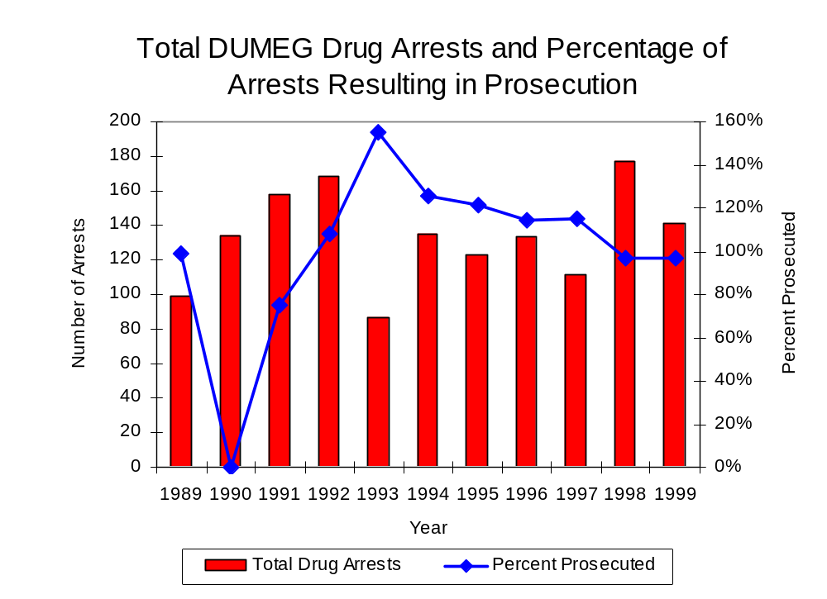
Figure 18
Source: DUMEG

Between 1989 and 1999, 68 percent (981) of the 1,441 drug offenders who were prosecuted as a result of DUMEG activity were convicted. Convictions for controlled substances accounted for 72 percent of all DUMEG initiated convictions during the period analyzed.

VI. Trends in Percent of Convicted Drug Offenders Sentenced to Prison

Anyone convicted of a felony in Illinois can be sentenced either to prison or probation, or receive conditional discharge. A number of factors influence the type and length of sentence imposed on convicted felons, including the severity of the crime, the offender’s criminal and social history, safety of the community and legislation affecting certain types of offenses. For some types of convictions, a sentence to prison is required by state statute.

Between 1989 and 1999, the number of offenders convicted of a felony and sentenced in DuPage County increased 24 percent, from 1,676 to 2,074. Between 1989 and 1999, the number of convicted felons sentenced to the Illinois Department of Corrections (IDOC) nearly doubled, from 642 to 1,247. While those numbers remained relatively stable between 1989 and 1995, the number more than doubled in 1996, and increased nearly every year thereafter. The proportion of felons sentenced to IDOC also increased during the same period, from 38 percent to 60 percent of total felony sentences. In 1999, 728 probation sentences were imposed on convicted felons in DuPage County, 29 percent less than in 1989 (Figure 19). As a result, the proportion of felons sentenced to probation decreased from 61 percent in 1989 to 35 percent in 1999. Sentences other than prison or probation account for the remaining felony sentences imposed in 1999.
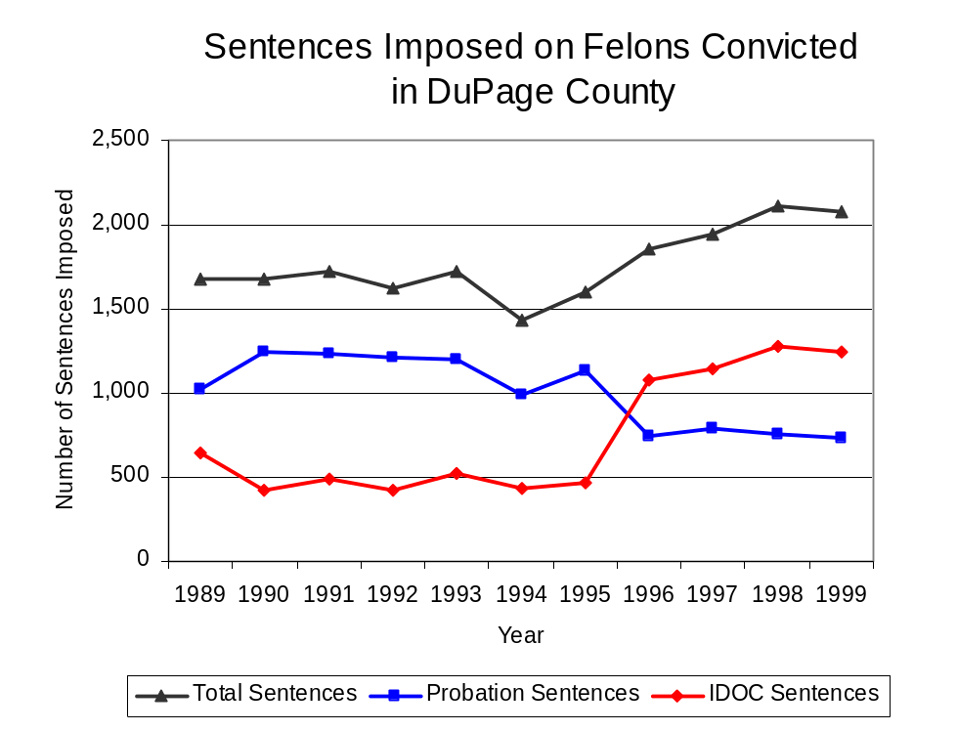
Figure 19
Source: Administrative Office of the Illinois Courts

Between 1989 and 1999, the number of DUMEG drug offenders convicted and sentenced more than doubled, from 35 to 95. During the period analyzed, the number of convicted DUMEG drug offenders sentenced to either prison or probation more than doubled, from 17 to 37 and from 12 to 27, respectively. The number of convicted DUMEG drug offenders sentenced to jail increased more than four-fold, from six to 31 (Figure 20). In 1999, among those DUMEG drug offenders convicted and sentenced, prison sentences accounted for the largest proportion (39 percent), followed by jail sentences (33 percent) and probation sentences (28 percent).
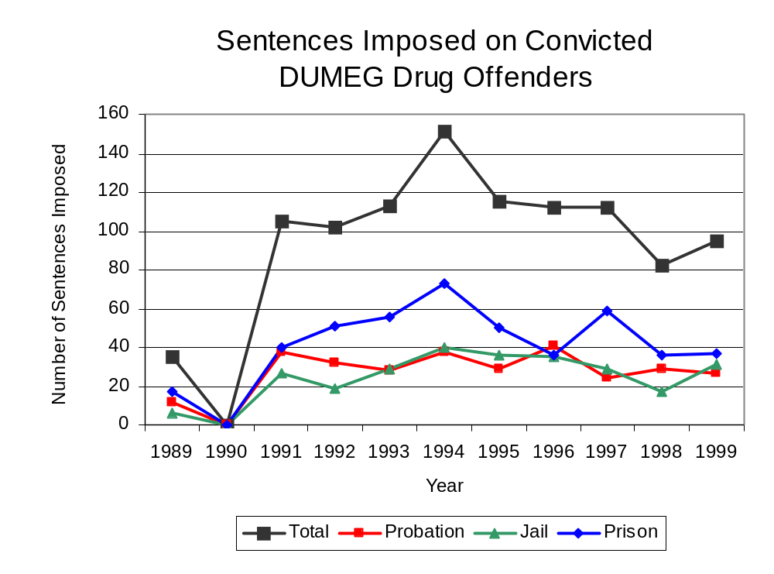
Figure 20
Source: DUMEG

Between state fiscal years 1989 and 1999, the number of new court commitments to IDOC’s Adult Division for drug offenses from DuPage County more than doubled, from 71 to 149. The number of drug offender admissions by DUMEG nearly tripled, from 13 to 37 between 1989 and 1999 (Figure 21). Thus, during the period analyzed, prison sentences resulting from DUMEG cases accounted for one-quarter of all drug-law violators sentenced to prison from the region where DUMEG operates.
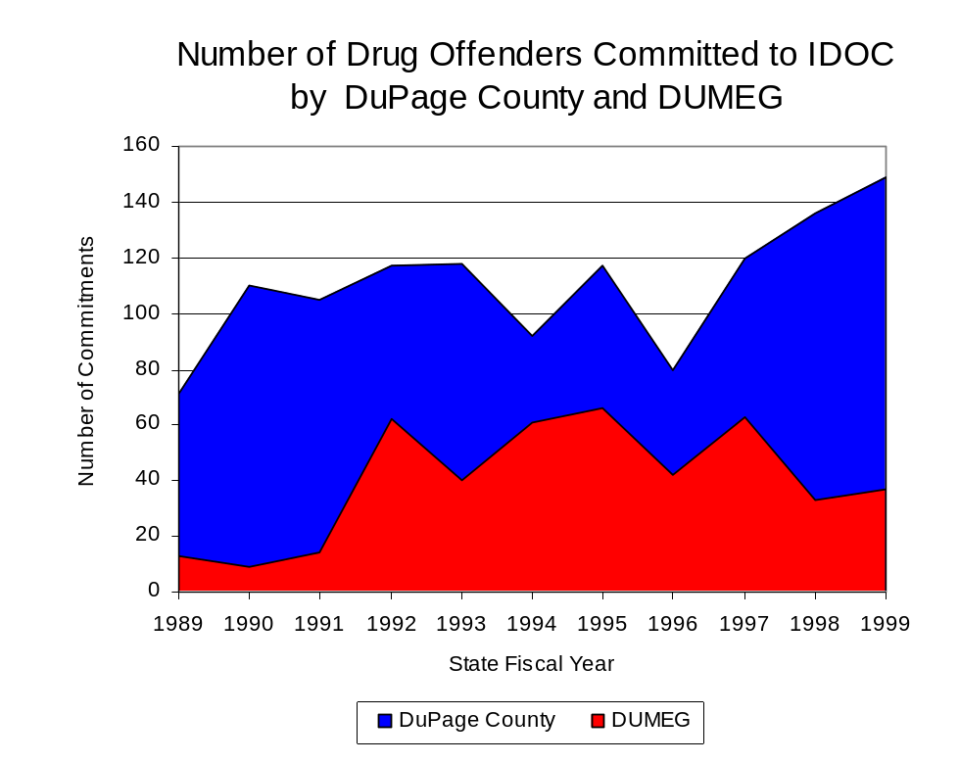
Figure 21
Source: Illinois Department of Corrections and DUMEG

During the period analyzed, the proportion of new court commitments to the Illinois Department of Corrections accounted for by drug offenders remained relatively stable. However, drug offenders accounted for a slightly increasing proportion of adults convicted and sentenced to prison from DuPage County. In 1989, drug offenses accounted for 20 percent of all commitments to IDOC, compared to 23 percent in 1999 (Figure 22).

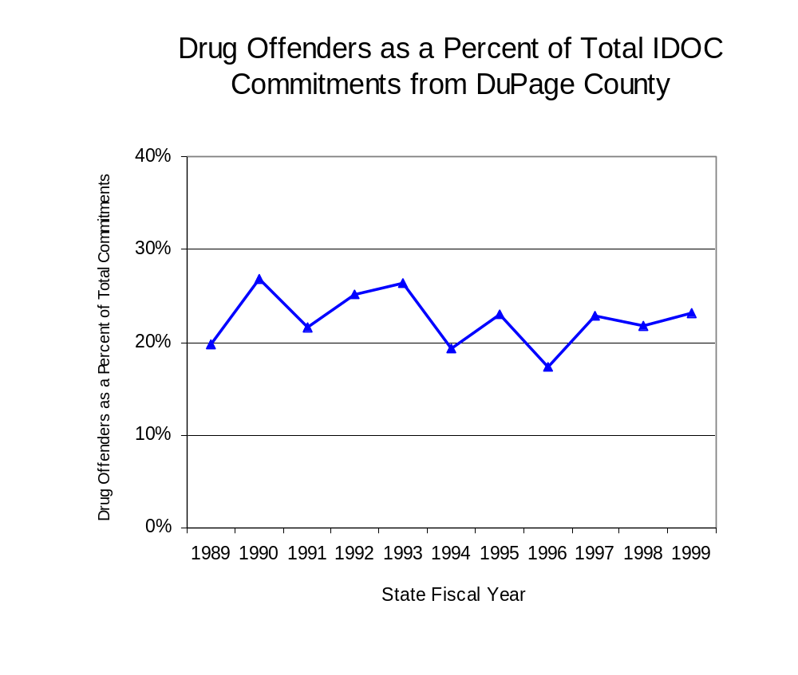
Figure 22
Source: Illinois Department of Corrections

Penalties for drug offenses were also examined between 1993 and 1999. Class 4 felonies accounted for the largest proportion (38 percent) of sentences to IDOC for drug offenses, followed by Class 1 felonies (25 percent), Class X felonies (22 percent), Class 2 felonies (12 percent) and Class 3 felonies (4 percent). Between 1993 and 1999, the number of Class 4 felony sentences increased more than three-fold, from 20 to 82, while Class 2 felony sentences increased more than tripled, from three to 11 and Class 1 felony sentences increased 21 percent, from 19 to 23. The number of Class 3 felonies decreased slightly, from four in 1993 to three in 1999, while Class X felonies decreased 30 percent, from 43 to 30, during the same period (Figure 23).

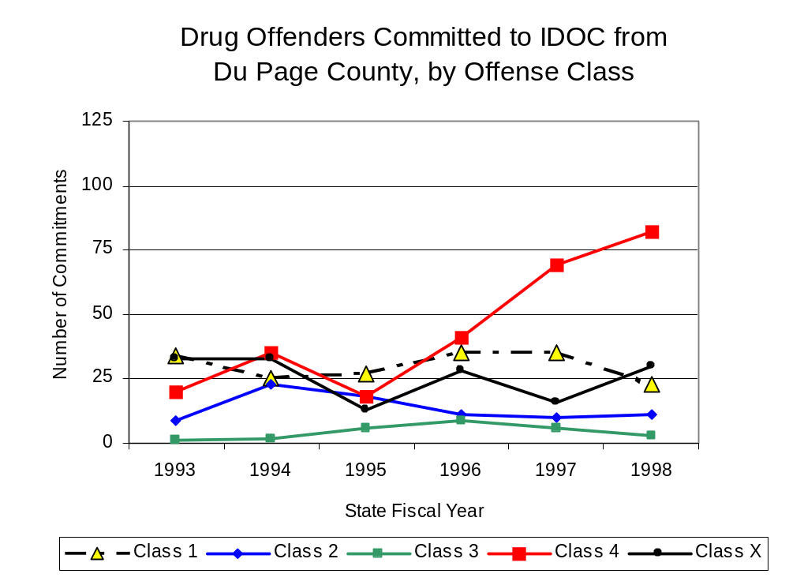
Despite the increase in Class 4 felony sentences to IDOC between 1993 and 1999, the mean sentence length for Class 4 felonies decreased from 2.3 to 1.9 years during the period, and mean sentence lengths for Class X felonies decreased from 9.3 to 8.6 years. Conversely, the mean sentence length for Class 2 felonies increased 50 percent, from 3 to 4.5 years, while the mean sentence for a Class 3 felony increased 42 percent, from 1.9 to 2.7 years, and Class 1 mean sentence lengths increased 18 percent, from 4.6 to 5.4 years.
Figure 23
Source: Illinois Department of Corrections

Based on data collected from the 2000 Illinois Adult Probation Outcome Study, more than one-quarter (26.5 percent) of all adults discharged from probation in DuPage County during the study period (November 2000) were convicted of drug-law violations. Of these drug-law violators discharged from probation in DuPage County, most (83.3 percent) had been convicted of a felony drug offense. In addition, more than three-quarters (83.3 percent) of these drug-law violators were ordered to participate in some form of treatment, and each was ordered to pay, on average, $818 in the form of supervision fees, court costs and fines.

VII. Trends in Drug Treatment Admissions in DUMEG Region by Drug Type

In addition to considering indicators of the extent and nature of drug abuse as reported through the criminal justice system (for example, arrests and prison sentences), there are indicators of substance abuse available from other Illinois social service agencies. Overseeing and supporting treatment for substance users, whether they are referred from the criminal justice system or elsewhere, is the responsibility of the Illinois Department of Human Services’ Office of Alcoholism and Substance Abuse (OASA). It is important to note, however, that while OASA data represent the majority of the overall demand for substance abuse treatment in the state, some private programs provide treatment services to a smaller but significant number of clients who may not be included in the state’s reporting system.

In state fiscal year 1999, OASA reported 1,595 admissions for alcohol or drug abuse treatment from DuPage County, 36 percent more than the 1,170 admissions in 1989 (Figure 24). Among the 1,595 admissions to substance abuse treatment in state fiscal year 1999, one-third (531) reported alcohol as their primary substance of abuse, while abuse of illicit substances accounted for two-thirds.

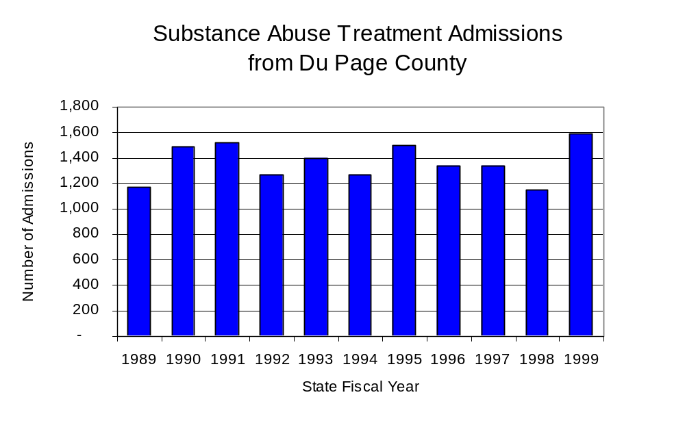
Figure 24
Source: Illinois Department of Human Services’
Office of Alcoholism and Substance Abuse
While drug treatment admissions can be considered a measure of the demand placed on a specific component of the human services system within Illinois, the extent and nature of drug treatment admissions could also be indicative of the substance abuse problem within a particular region. In some respects, the characteristics of those admitted to drug treatment can be considered a profile of the most serious drug abusers in the community, since admission to treatment requires a documented, formal assessment of a drug problem and a level of substance abuse warranting treatment. By comparing the types of drugs of abuse reported by those admitted to substance abuse treatment with the types of drugs involved in law enforcement agency arrests, one can get a sense of the degree to which arrests reflect the drugs which are most problematic within a community.

In the following analyses, the percent of arrests accounted for by drugs classified under Illinois’ Controlled Substances Act (primarily cocaine, heroin, and methamphetamine) versus the Cannabis Control Act (marijuana) across the participating agencies combined, non-participating agencies combined and DUMEG are compared to the proportion of drug treatment admissions accounted for by these groups of substances. From these comparisons, a number of general conclusions can be made. First, the proportion of arrests made by DUMEG accounted for by drugs other than marijuana (Controlled Substances Act offenses) was very close to the proportion of drug treatment admissions from the covered region accounted for by these substances. Thus, there is considerable convergence between the drugs involved in DUMEG arrests and treatment admissions. On the other hand, the majority of arrests by local police departments (including those participating in DUMEG and non-participating agencies) were for cannabis offenses. Thus, while local arrests may reflect the most widely available and used drug in the region, they tend not to involve the substances considered to be most serious (i.e., felony versus misdemeanor) nor the substances individuals are seeking and receiving treatment for (Figure 25).

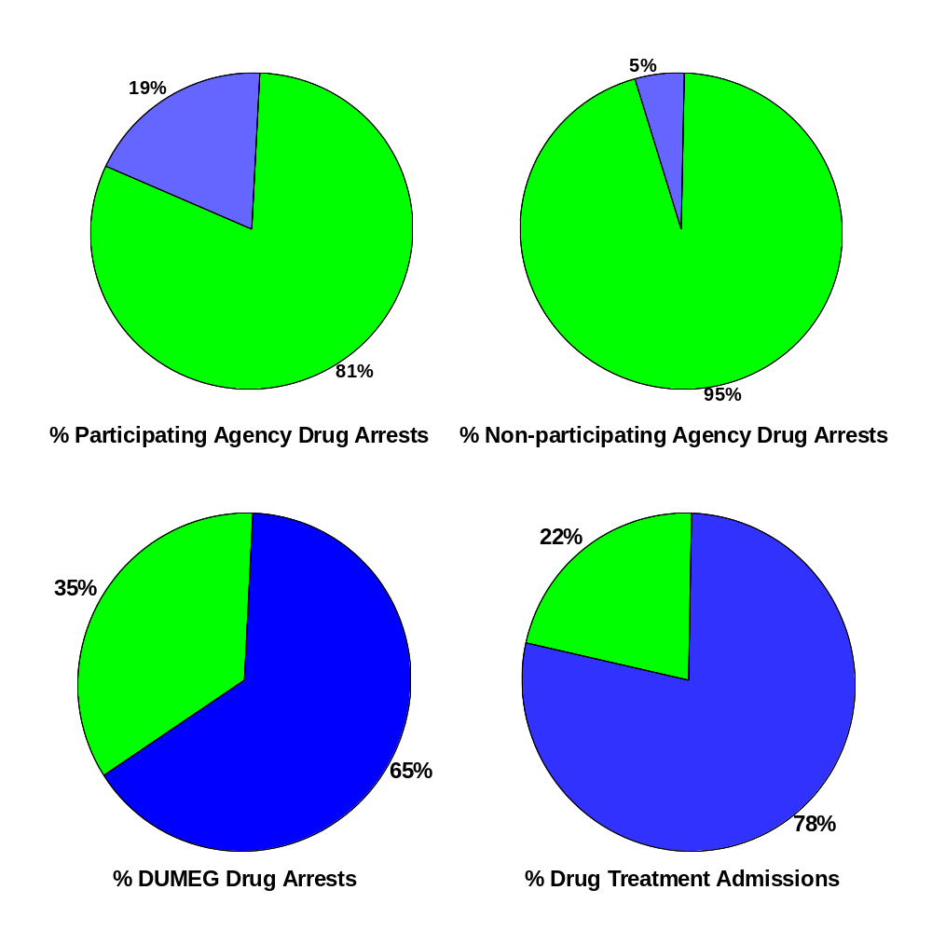
Source: ICJIA calculations using Illinois Department of Human Services’ Office of Alcoholism and Substance Abuse and DUMEG data

CannabisControlled Substances
Comparison of Drug Arrests by DUMEG and Participating and
Non-participating Agencies vs. Drug Abuse Treatment Admissions in DuPage County, 1999
Figure 25

VIII. Trends in Drug Exposed Births

Illinois continues to experience the effects of prenatal substance abuse. In Illinois, if a baby is born and thought to have been exposed to illegal substances or alcohol, either through observation by physicians or toxicology tests, the case is reported to the Illinois Department of Children and Family Services. These cases are then investigated by DCFS to verify the child’s prenatal exposure to either alcohol or illegal substances. Between state fiscal years 1989 and 1999, nearly one-half (50) of Illinois’ 102 counties reported at least one case of a substance-affected infant.

Between state fiscal years 1989 and 1999, the number of drug-exposed infant cases reported in DuPage County decreased 18 percent, from 22 to 18. Between state fiscal years 1989 and 1999, 181 cases, or 88 percent of all cases reported, were verified as involving prenatal drug use by a DCFS investigation. Mirroring the trend of reported cases, verified cases of drug-exposed infants in the DUMEG region also decreased between 1989 and 1999, from 21 to 16 (Figure 26).
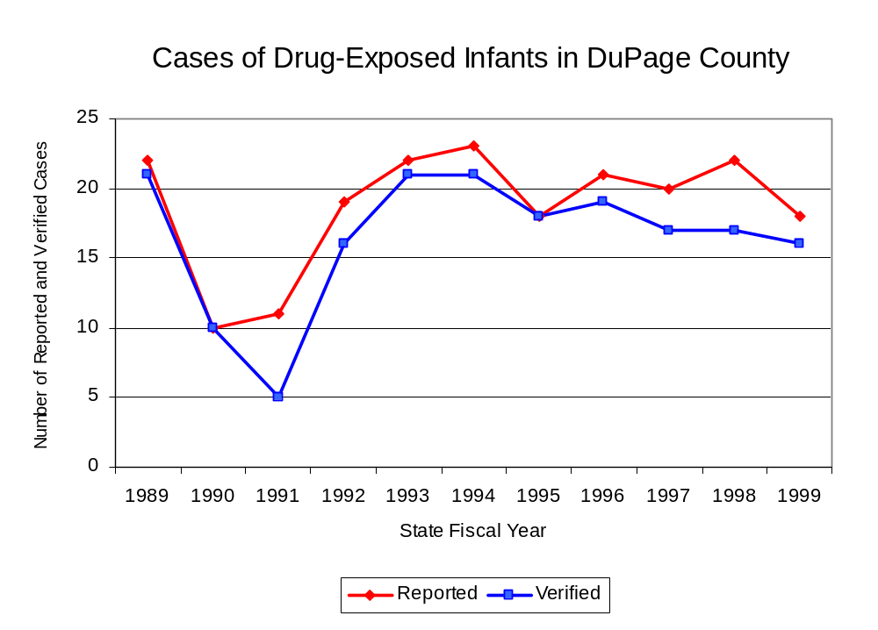
Source: Department of Children and Family Services
Figure 26
IX. Summary of Drug Situation

Although the distribution of illegal drugs is difficult to measure precisely, data obtained from criminal justice sources can be helpful in estimating drug availability. Information from a recent survey of Illinois drug enforcement units, as well as the most up-to-date data available on drug price, are presented as indicators of the drug supply in Illinois.

In 1995, 1996 and 1998, the Authority conducted a survey of each MEG and task force in Illinois to gauge the perceived availability of drugs in the areas they cover. Questions were asked concerning the availability of specific drugs, and results were analyzed by region of the state. MEGs and task forces are classified as being urban, rural or mostly urban based upon the classification of the county(s) that each unit covers, and, for purposes of this report, are compared to the average of similar units.

According to DUMEG survey responses, cannabis, cocaine and crack continued to be the most visible drugs on the street and were all reported to be “readily available” across all regions analyzed. The perceived availability of most drugs remained relatively unchanged in the region covered by DUMEG. The perceived availability of crack, cocaine and heroin has increased slightly in the region covered by DUMEG since the 1996 survey, while these drug types have remained unchanged in all MEGs and task forces in mostly urban regions similar to DUMEG. Methamphetamine was reported as moderately available across Illinois but available to a somewhat lesser degree in DuPage County and by all MEGs and task forces in mostly urban regions. Also, LSD appears to be more readily available in all other MEGs and task forces in mostly urban regions than in DuPage County and across Illinois (Figure 27).
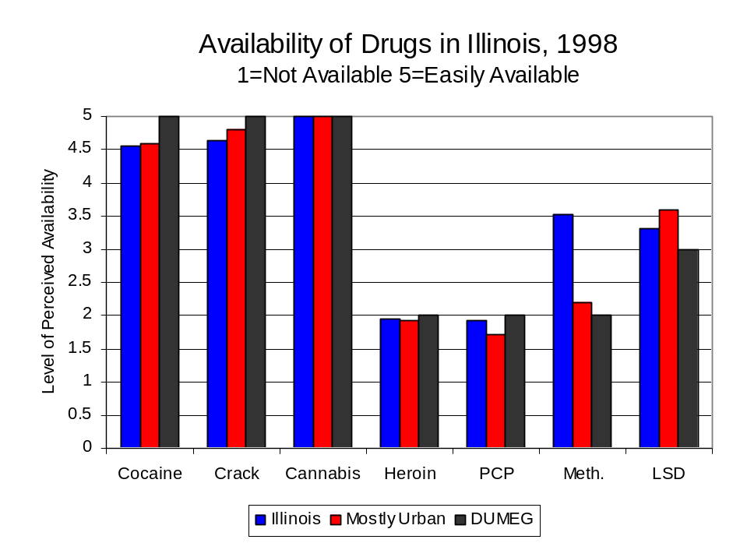
Figure 27
Source: Authority Survey of Illinois MEGs and task forces
Another market indicator that can be used to assess availability is drug price. Lower prices tend to suggest a sufficient supply to meet demand, while increasing prices indicate decreased availability.

Based on a statewide survey of MEG and task force units, the average price of cocaine, crack, cannabis and heroin appear to be relatively stable across all regions surveyed in 1998, while prices for PCP and methamphetamine appear to vary somewhat across Illinois. The average price of cocaine and crack in DuPage County and in the other mostly urban regions, between 1996 and 1998, while it increased across Illinois. The 1998 average price of cocaine reported by DUMEG was $80 per gram, compared to $98 per gram across Illinois and $89 per gram reported by all MEGs and task forces in other mostly urban regions (Figure 28). In 1998, the average price of cannabis was reported as approximately $10 per gram in the DUMEG region, $11 per gram in primarily mostly urban regions and $8 per gram across Illinois.

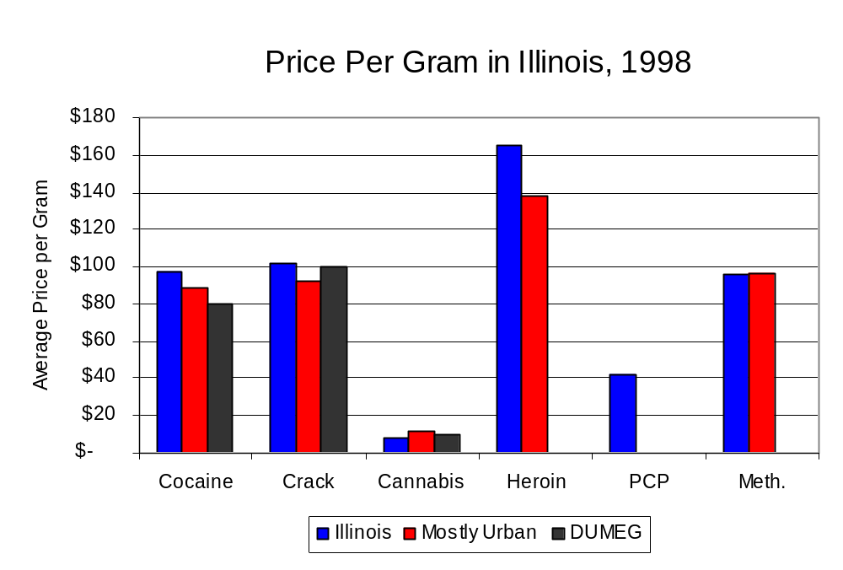
Figure 28
Source: Authority Survey of Illinois MEGs and task forces

X. Appendices

1999 Percent of Illinois'
County-level Population Covered by an Authority-funded Multi-jurisdictional Enforcement Group or Task Force
Map 1
* Shaded counties indicate that at least one law enforcement agency within the county participates in a MEG or task force
Percent of County Population Covered by MEG or Task Force

1999 Illinois
Cannabis
Seizure Rates, by County
Map 2
Cannabis Seizure Rate
(rate per 100,000 population)
1999 Illinois
Cocaine
Seizure Rates, by County
Map 3
Cocaine Seizure Rate
(rate per 100,000 population)
1999 Illinois Methamphetamine
Seizure Rates, by County
Map 4
Methamphetamine Seizure Rate
(rate per 100,000 population)
XI. Bibliography

Administrative Office of the Illinois Courts, Annual Report to the Supreme Court of Illinois.
1989 through 1999 reports, Springfield, Illinois.

Administrative Office of the Illinois Courts’ Probation Division, Statewide Probation Data
Report. 1989 through 1999 reports, Springfield, Illinois.

Illinois Department of Human Services’ Office of Alcoholism and Substance Abuse. Data
provided for state fiscal years 1989 through 1999, Springfield, Illinois.

Illinois Department of Children and Family Services, Child Abuse/Neglect Statistics Report,
1989 through 1999 reports, Springfield, Illinois.

Illinois Department of Corrections. Data provided for fiscal years 1989 through 1999,
Springfield, Illinois.

Illinois State Police, Crime in Illinois. 1993 through 1999 reports, Springfield, Illinois.

Illinois State Police, Drug Statistics Report. Monthly reports, January 1989 through
December 1999, Springfield, Illinois.

DuPage County Metropolitan Enforcement Group. Monthly reports, January 1989 through
December 1999, Lisle, Illinois.

U.S. Bureau of the Census.


George H. Ryan, Governor
Peter B. Bensinger, Chairman
Candice M. Kane, Executive Director

